9:00 – 9:20 Adding Background


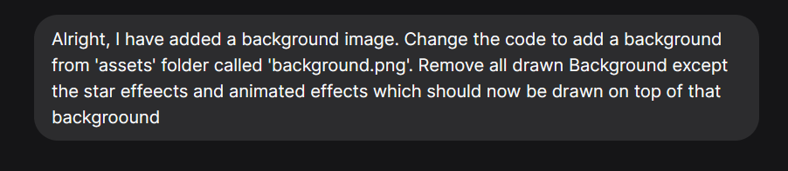
And it worked immediately!
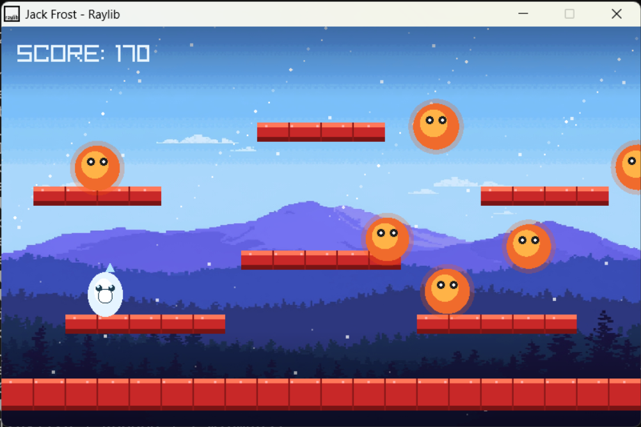
9:20 – 9:40 Improving Enemy Behaviour
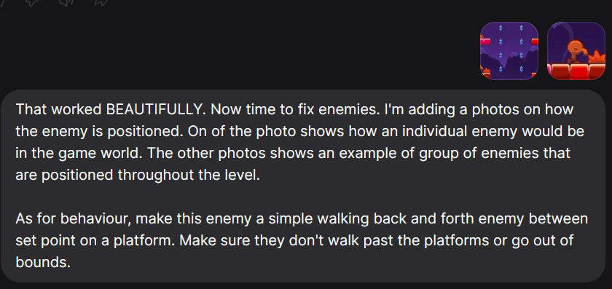
 oof
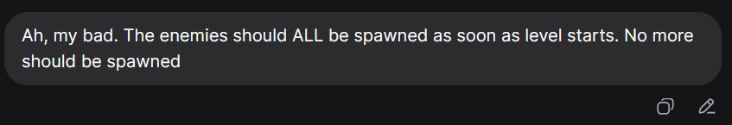

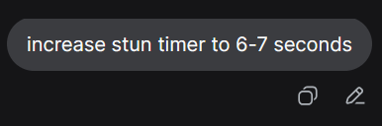
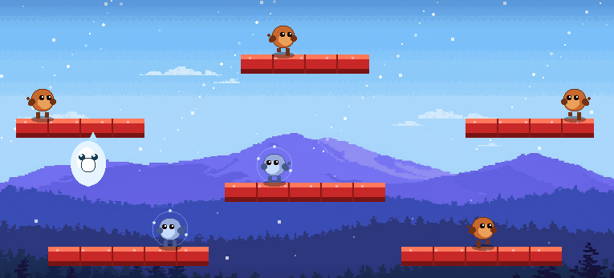
Enemies woooooo

9:40 – 10:20 - Adding second enemy
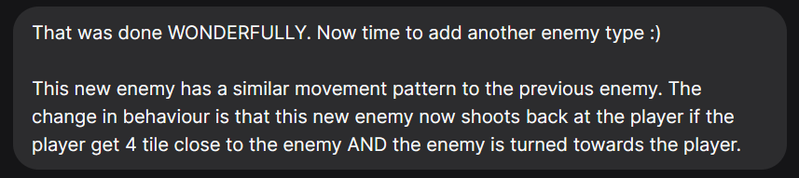

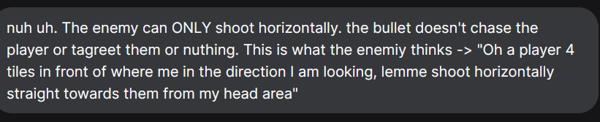

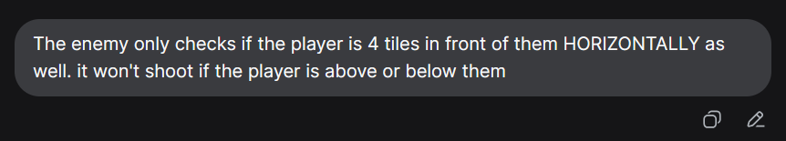
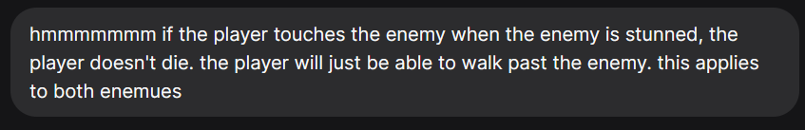

10:20 – 10:40 – Figuring out the background issue (background not working on UNI devices)



10:40 - 10:50 Catching up with the AI
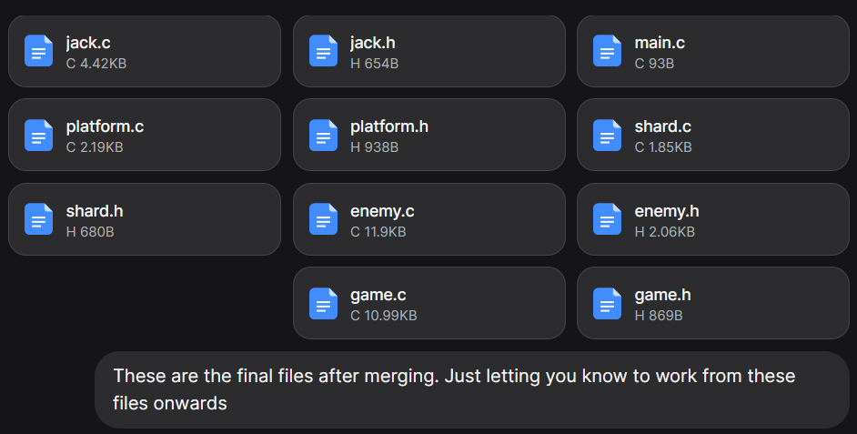
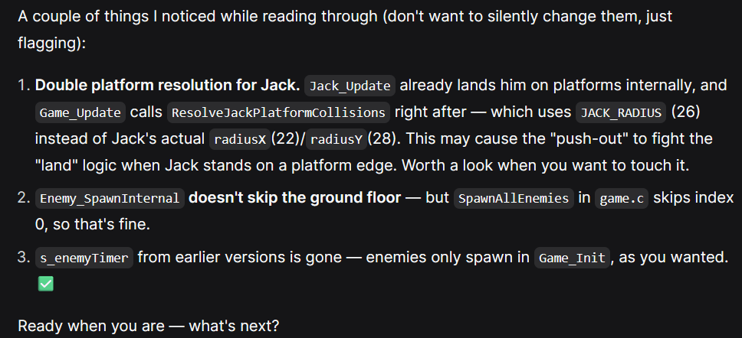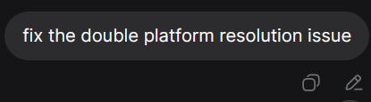

10:50 – 11:00 – Adding a second player
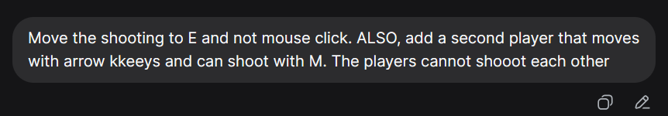
Worked immediately!!

